Coursera, IBM
Databases and SQL for Data Science with Python

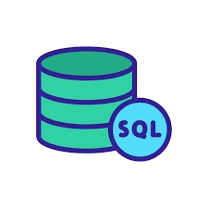

05/11/23
Table Of Content
1. Week 1 4
1.1. SELECT Statement 4
1.2. COUNT, DISTINCT, LIMIT Statements 4
1.3. INSERT Statement 5
1.4. UPDATE, DELETE Statements 6
2. Week 2: Introduction to Relational Databases and Tables 7
2.1. Relational Database Concepts 7
2.2. Types of SQL Statements (DDL vs DML) 13
2.3. CREATE TABLE Statement 15
2.4. ALTER, DROP and TRUNCATE 17
3. Week 3: Intermediate SQL 22
3.1. Refining Result and Searching 22
3.1.1. Using String Patterns and Ranges 22
3.1.2. Sorting Result Sets 24
3.1.3. Grouping Result Sets 27
3.2. Functions, Multiple Tables, and sub-queries 30
3.2.1. Built-in Database Functions 30
3.2.2. Date & Time Built in functions 32
3.2.3. Hands-on Lab: Built-in functions 35
3.2.4. Sub-Queries and Nested Selects 35
3.2.5. Hands-on Lab : Sub-queries and Nested SELECTS 38
3.2.6. Quering Multiple Tables 39
3.2.7. Hands-on Lab: Working with Multiple Tables 42
3.2.8. SQL Cheat Sheet: FUNCTIONS and Implicit JOIN 42
4. Week 4: Accessing Databases Using Python 43
4.1.1. Access Database Using Python 43
4.1.2. Hands-on Lab: Creating tables, inserting and querying Data 46
4.1.3. Connecting to a database using ibm_db API 46
4.1.4. (Optional) Db2 Lab: Create Database Credentials 47
4.1.5. (Optional) Db2 Lab: Connecting to a database instance 47
4.1.6. Creating tables, loading data and querying data 48
4.1.7. (Optional) Db2 Lab: Creating tables, inserting and querying Data 50
4.1.8. Hands-on Tutorial: Accessing Databases with SQL magic 50
4.1.9. (Optional) Db2 Lab: Tutorial, Accessing Databases with SQL magic 50
4.1.10. Analyzing Data Using Python 50
4.1.11. (Optional) Db2 Lab: Analyzing a real World Data Set 50
5. Week 4 52
6. Week 6: 53
6.1. Heading 2 53
6.1.1. Heading 3 53
6.2. Heading 2 53
6.2.1. Heading 3 53
7. Guides 54

Week 1

SELECT Statement
- Select statement: get what I need from database
- Conditions:
  - ( > bigger than, >= biggerthan or equal, < less than, <= lessthan or equal, = equal, <> not equal)

- SELECT col1,col2 FROM DataBaseName WHERE condition;

- SELECT * FROM FilmLocations;
- SELECT Locations, FunFacts FROM FilmLocations;
- SELECT Title, ReleaseYear, Locations FROM FilmLocations WHERE ReleaseYear<=2000;
- SELECT Title, ProductionCompany, Locations, ReleaseYear FROM FilmLocations WHERE Writer<>"James Cameron";

COUNT, DISTINCT, LIMIT Statements
- COUNT: count number of rows
  - SELECT COUNT(col) FROM DataBaseName WHERE col_condition;
  - SELECT COUNT(*) FROM FilmLocations; -> 3414
  - SELECT COUNT(Locations) FROM FilmLocations WHERE Writer="James Cameron"; -> 48

- DISTINCT: select of unrepeatable rows

  - SELECT DISTINCT col FROM DataBaseName WHERE col_condition;
  - SELECT DISTINCT Title FROM FilmLocations;
  - SELECT COUNT(DISTINCT ReleaseYear) FROM FilmLocations WHERE ProductionCompany="Warner Bros. Pictures";
  - SELECT DISTINCT Title, ReleaseYear FROM FilmLocations WHERE ReleaseYear>=2001;

- LIMIT: select specific number of rows
  - select * from DataBaseName WHERE col_condition LIMIT 10 OFFSET 5;
  - SELECT * FROM FilmLocations LIMIT 15 OFFSET 10; -> skip 10 rows, begin at 11 to 10+15 (25)
  - SELECT DISTINCT Title FROM FilmLocations WHERE ReleaseYear=2015 LIMIT 10;

INSERT Statement
- Data Modifying Language DML: Read and Modify the Data
- INSERT: adding row into table (DML)
  - INSERT INTO DataBaseName(col1,col2,…,coln)
VALUES (‘a1’,’m2’,…,’zn’) → row 1
,(‘q1’,’m3’,…,’gn’); → row 2

UPDATE, DELETE Statements
- UPDATE: Modify row (DML)
  - UPDATE DataBaseName
SET col1 = ‘abc’ , col2 = ‘efg’
WHERE col_condition;

- DELETE: delete row (DML)
  - DELETE FROM DataBaseName
WHERE col_condition;
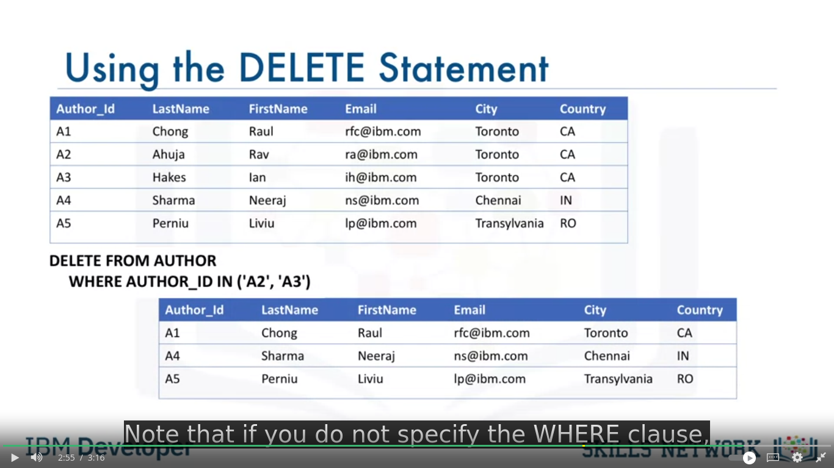
Click here for cheatsheet

Week 2: Introduction to Relational Databases and Tables

Relational Database Concepts
- ERM → Entities [tables] (one per column) and attributes [columns] (attached to one entity)
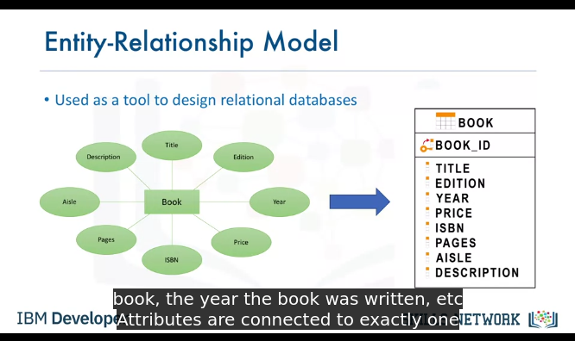
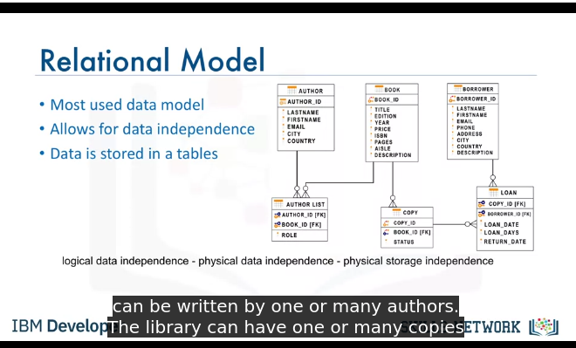
- attributes could be any datatype
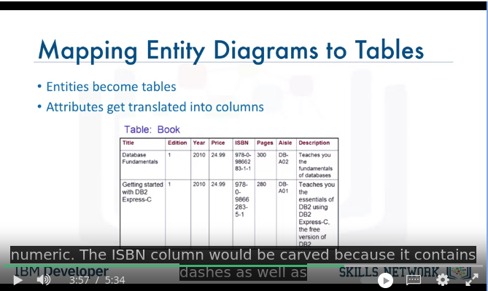
.
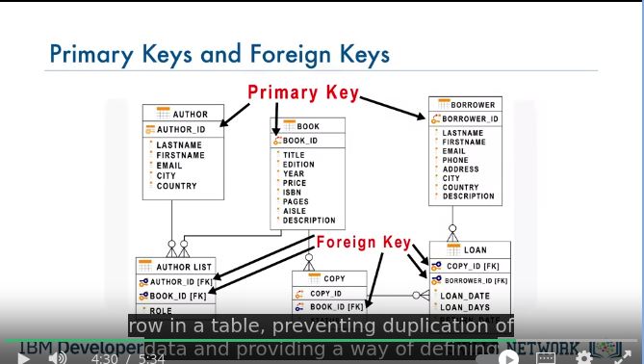

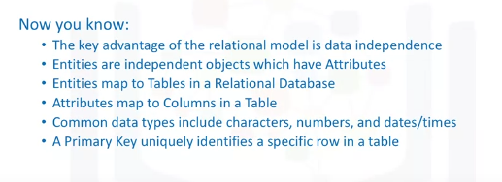

Types of SQL Statements (DDL vs DML)
- Data Definition and Data Manipulation
- DDL → define, change, or drop data
- DDL → CREATE (create table and its columns), ALTER (modifications within table), TRUNCATE (deleting data within table), DROP (delete the table)

- DML → read and modify
- DML → CRUD Operations responsible (Create Read Update Delete)
- DML → INSERT, SELECT, UPDATE, DELETE

CREATE TABLE Statement
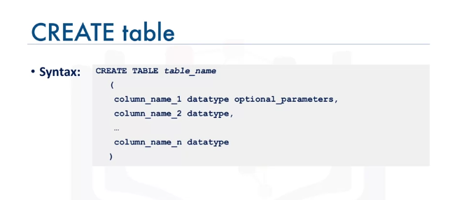
.
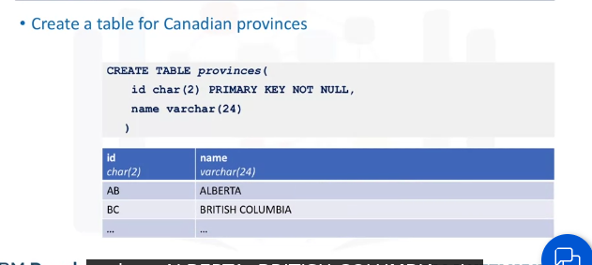
.

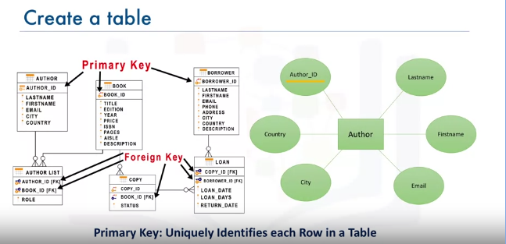
.
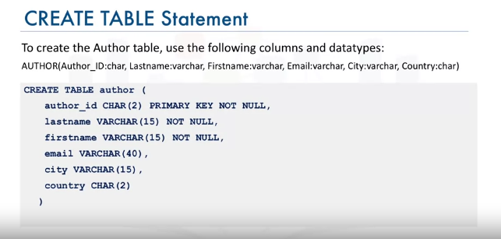
- PRIMARY KEY → uniquely identification, for no multiple data
- NOT NULL → ensures that this data cannot be null value
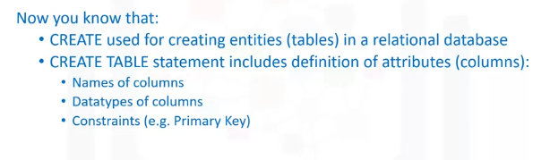

ALTER, DROP and TRUNCATE
- ALTER TABLE
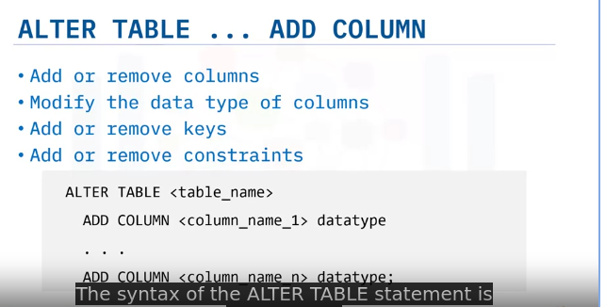
.
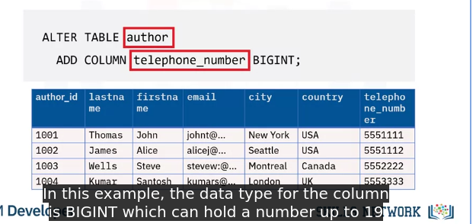
.

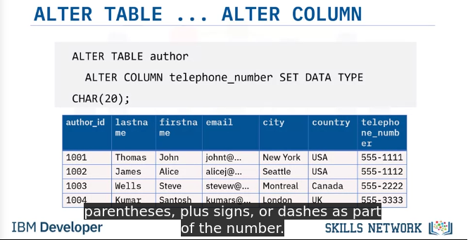
.
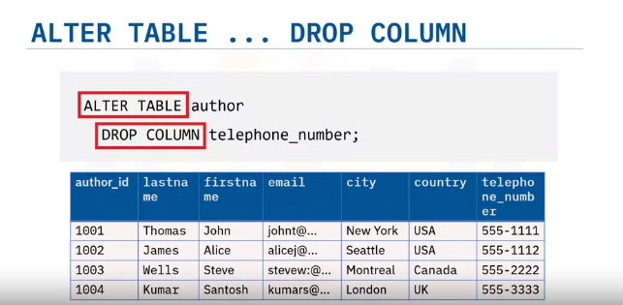
.
- TRUNCATE TABLE, this would remove content without removing the table itself
- Examples to ALTER and TRUNCATE tables using MySQL
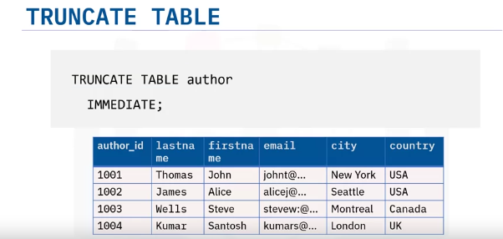
- DROP TABLE: remove all the table
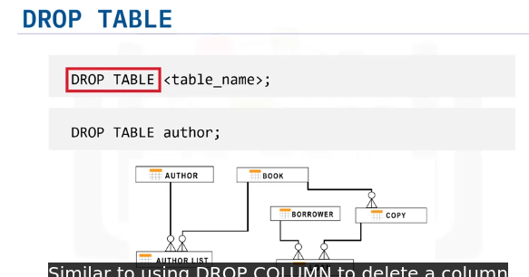
.
- Reading: Examples to CREATE and DROP tables (5 mins)
- SQL Cheat Sheet: CREATE TABLE, ALTER, DROP, TRUNCATE
- (Optional)Hands-on Lab: CREATE, ALTER, TRUNCATE, DROP

Week 3: Intermediate SQL

Refining Result and Searching

Using String Patterns and Ranges
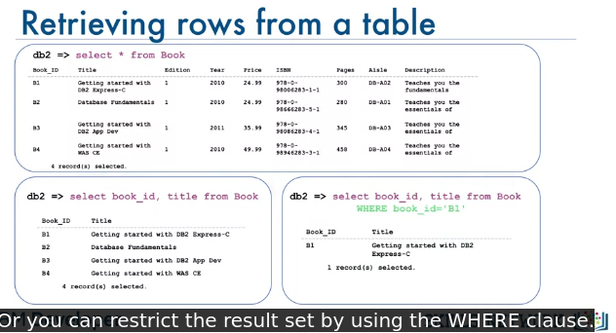
- Like → Using String Pattern
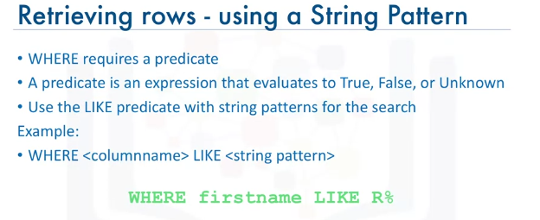
.
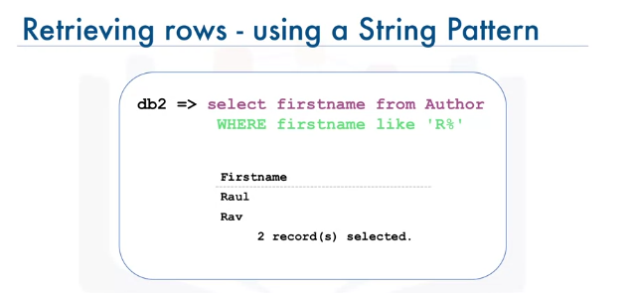
- Using Range
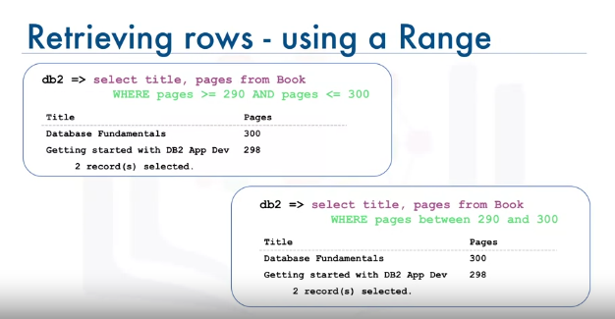
- Using Set Of Values
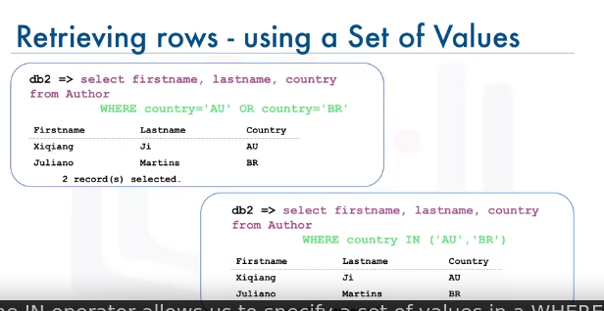
.

Sorting Result Sets
- Ascending form
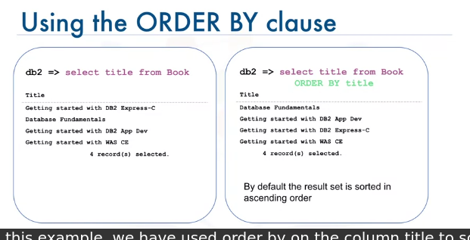
- Descending Form
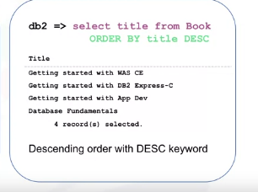
- Ascending by column number
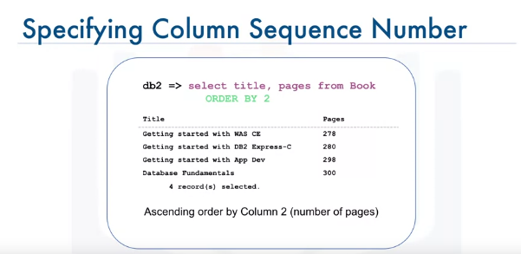

Grouping Result Sets
- Eliminate duplicates
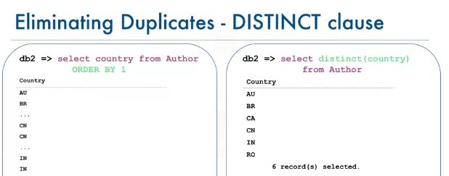
- group by → count number of attributes, 2 in Country is column number
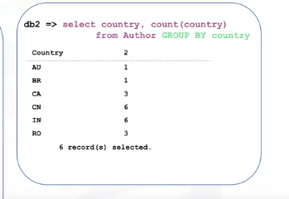
- group by, without adding column number
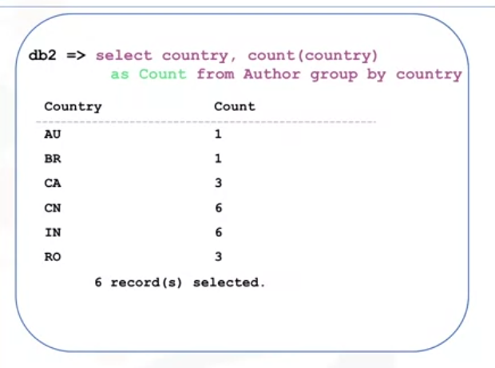
- having → limit number of rows
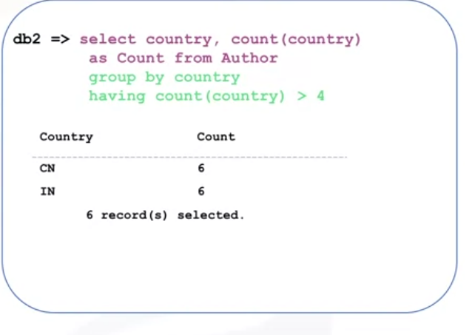
- to retrieve the average salary for all employees in the EMPLOYEES table, issue the query: SELECT AVG(SALARY) FROM EMPLOYEES;.
- SELECT DEP_ID, COUNT(*) AS "NUM_EMPLOYEES", AVG(SALARY) AS "AVG_SALARY" FROM EMPLOYEES GROUP BY DEP_ID; → selecting dep_id, count it and rename as NUM_EMPLOYEES, calculate average of each dep_id and rename it also
- Hands-on Lab: String Patterns, Sorting and Grouping
- (Optional) Db2 Lab: String Patterns, Sorting & Grouping
  - solution script
- SQL Cheat Sheet: Intermediate - LIKE, ORDER BY, GROUP BY

Functions, Multiple Tables, and sub-queries

Built-in Database Functions
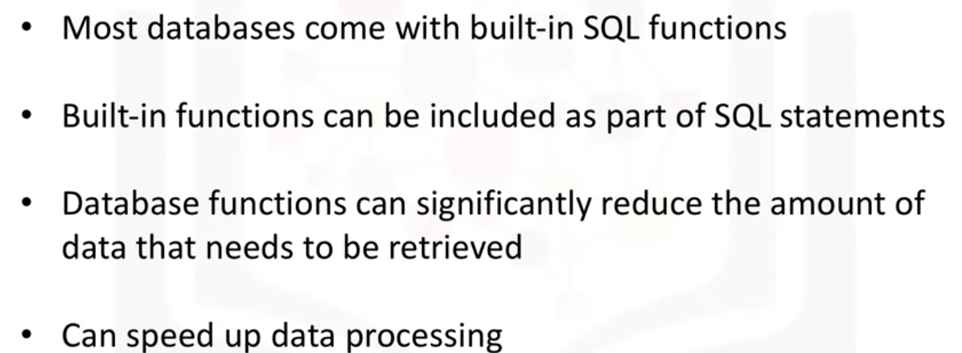
.
- agg or column functions: SUM(col), min,max,avg
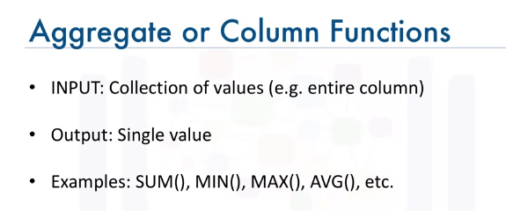
.
- example:
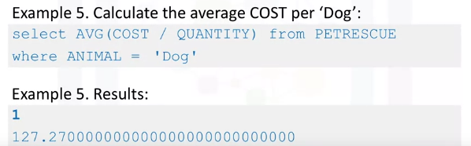
.
- Scalar functions → ROUND(col,num_decimals) → approx / LENGTH() → return num of characters / UCASE() → return uppercase / LCASE()
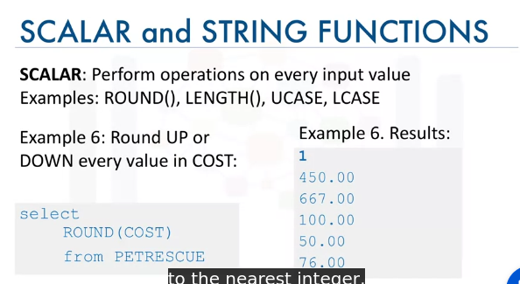
.
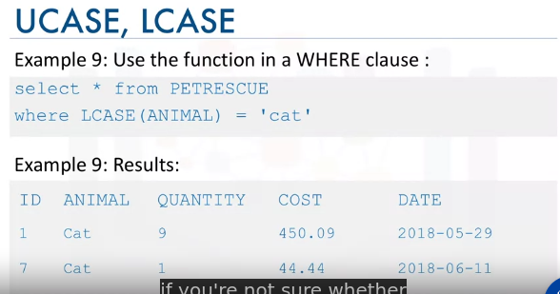

Date & Time Built in functions

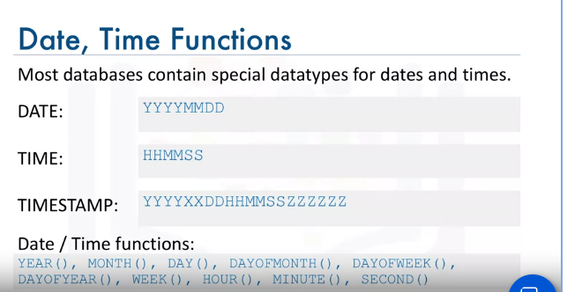
.
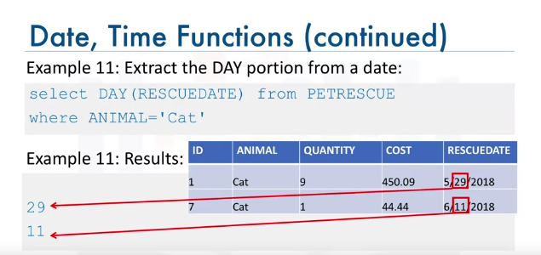
.
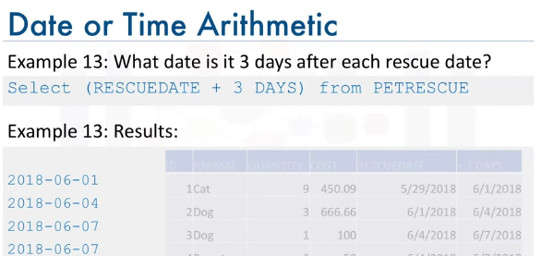
.
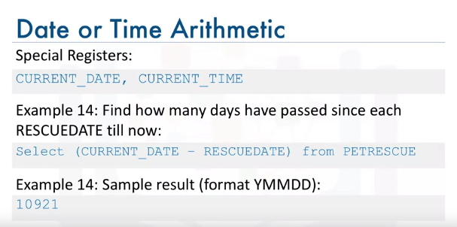
- SELECT DATE_ADD(RESCUEDATE, INTERVAL 3 DAY) FROM PETRESCUE → add 3 days to extracted date
- SELECT DATE_SUB(RESCUEDATE, INTERVAL 3 MONTHS) FROM PETRESCUE → subtract 3 months from extracted date
- SELECT DATEDIFF(CURRENT_DATE, RESCUEDATE) FROM PETRESCUE → return difference in dates
- SELECT FROM_DAYS(DATEDIFF(CURRENT_DATE, RESCUEDATE)) FROM PETRESCUE → same as above, but in YYYY-MM-DD format

Hands-on Lab: Built-in functions
- Hands-on Lab: Built-in functions
- (Optional) Db2 Lab: Built-in functions

Sub-Queries and Nested Selects
- Sub Queries → search for queries in another one
- ex: select F_NAME, L_NAME from EMPLOYEES where DEP_ID = (select max(DEP_ID) from EMPLOYEES) → where dep_id = 5
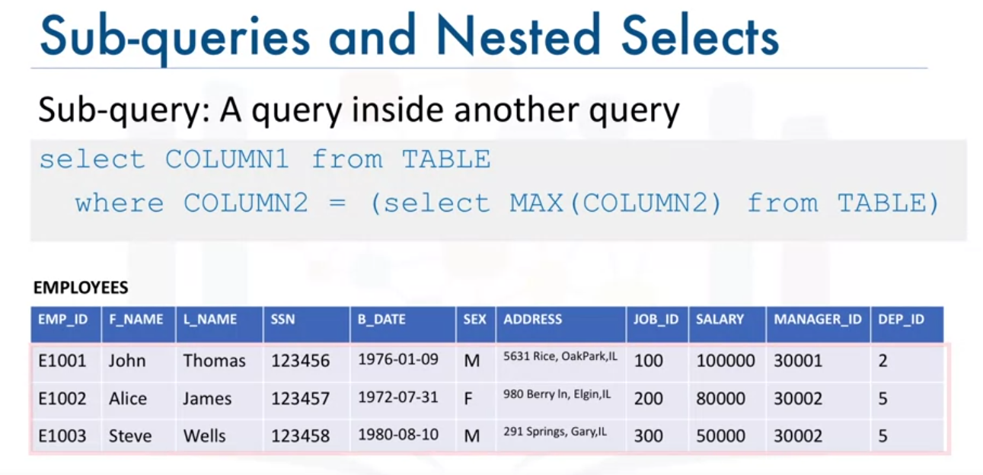
.
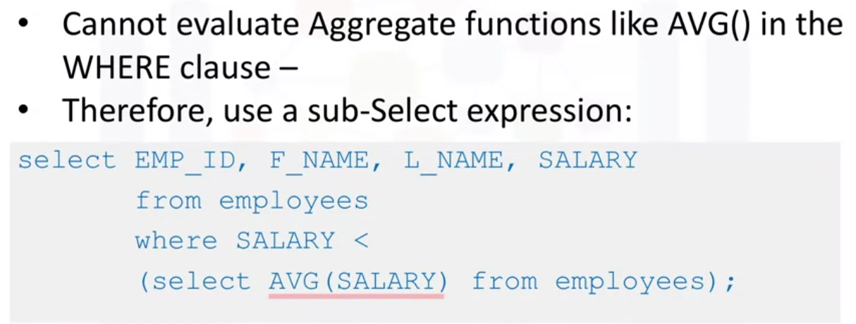
.
- avoid errors of aggregate functions usage by using column expressions (groupby error for multiple output of same value)
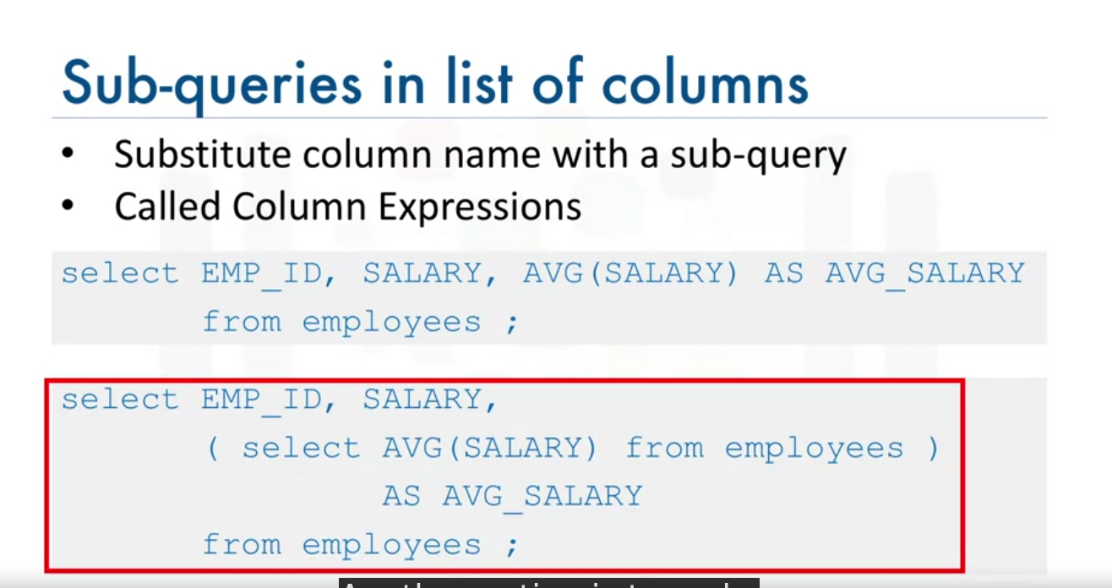
.
- SELECT AVG(START_DATE) FROM JOB_HISTORY → single row

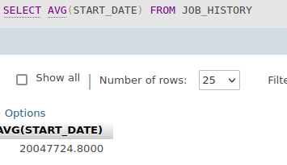

- SELECT (SELECT AVG(START_DATE) FROM JOB_HISTORY) FROM JOB_HISTORY → multiple rows
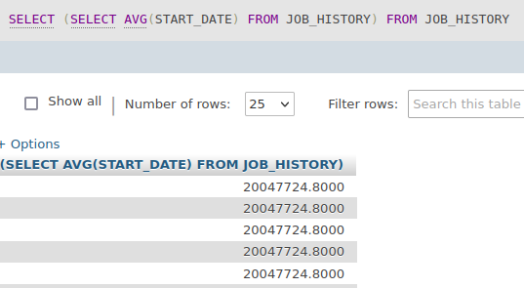
- create sub table by table expressions
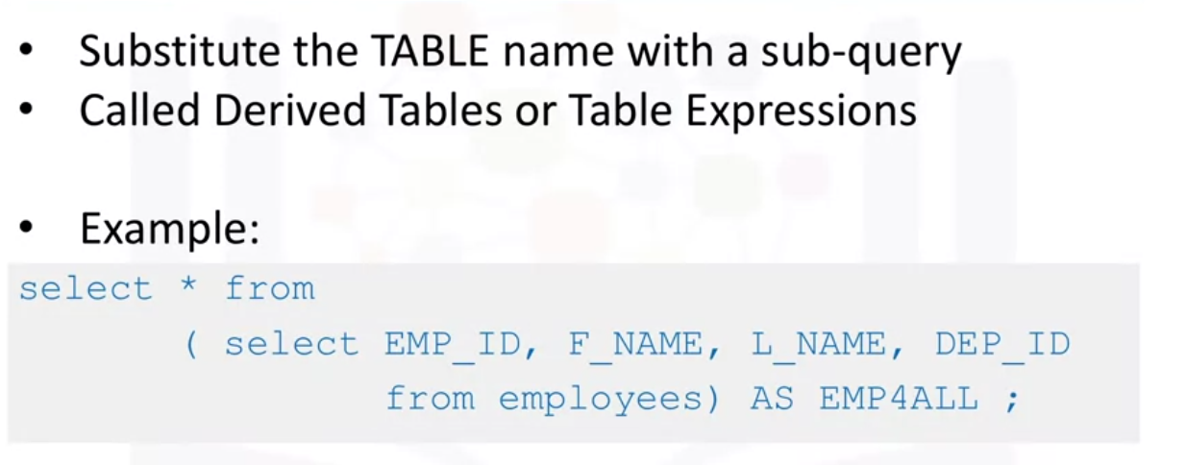
.

Hands-on Lab : Sub-queries and Nested SELECTS
- Hands-on Lab : Sub-queries and Nested SELECTS
- (Optional) Db2 Lab: Sub-queries and Nested SELECTs
  - Solution Script

Quering Multiple Tables
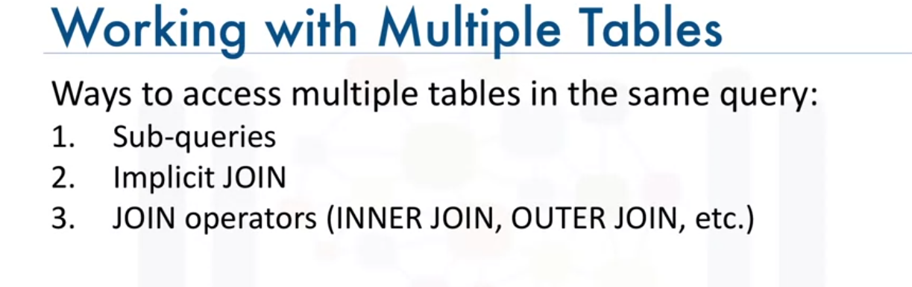
.
- access from another table
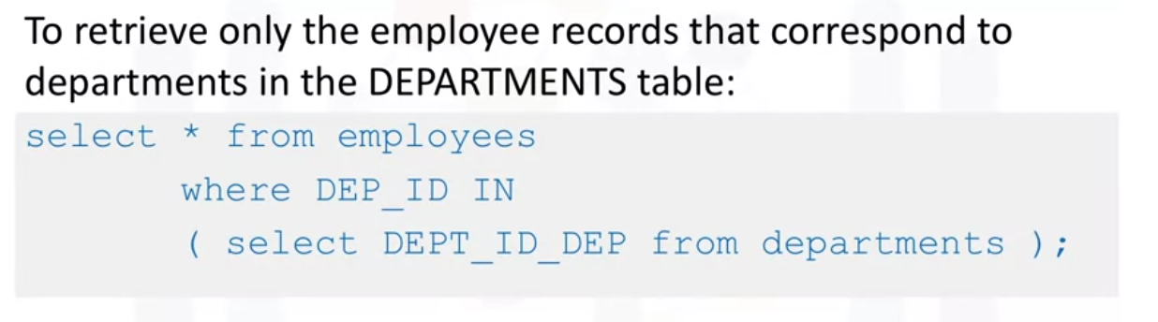
.
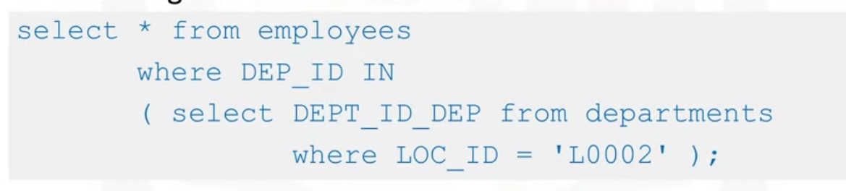
- Join implicit (cartesian join) → concatenate showing of tables
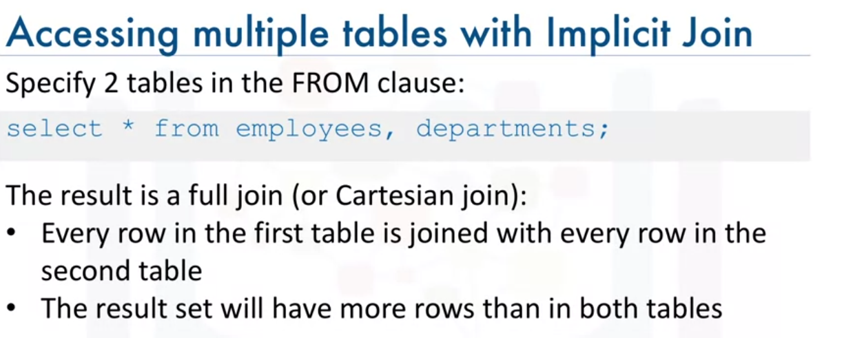
. * columns not rows NOTE
- using operands for limiting results
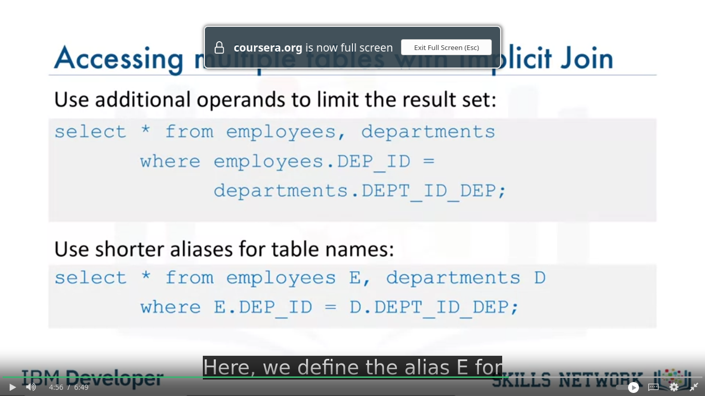
.
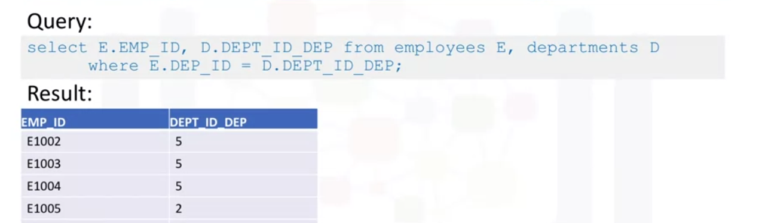

Hands-on Lab: Working with Multiple Tables
- Hands-on Lab: Working with Multiple Tables
- (Optional) Db2 Lab: Working with Multiple Tables
  - Solution Script

SQL Cheat Sheet: FUNCTIONS and Implicit JOIN
- SQL Cheat Sheet: FUNCTIONS and Implicit JOIN

Week 4: Accessing Databases Using Python

Access Database Using Python
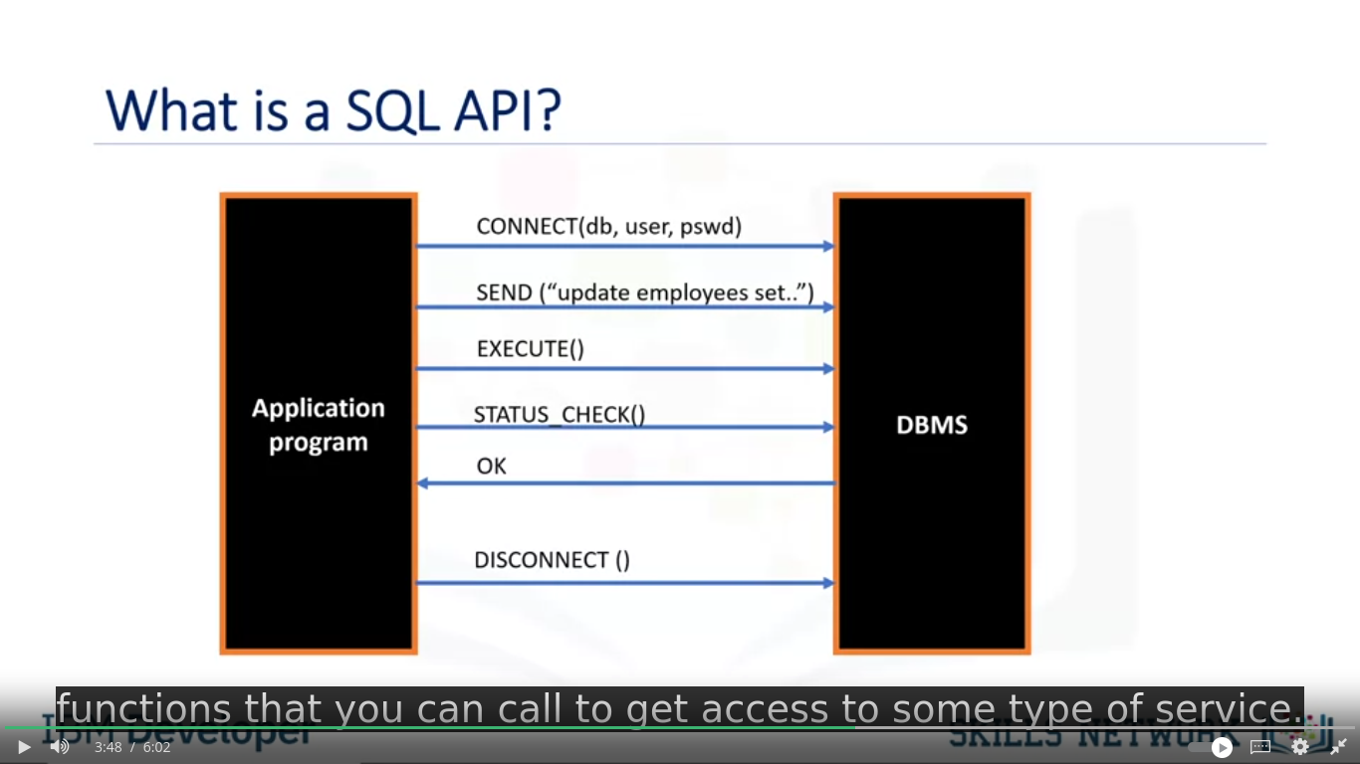
.
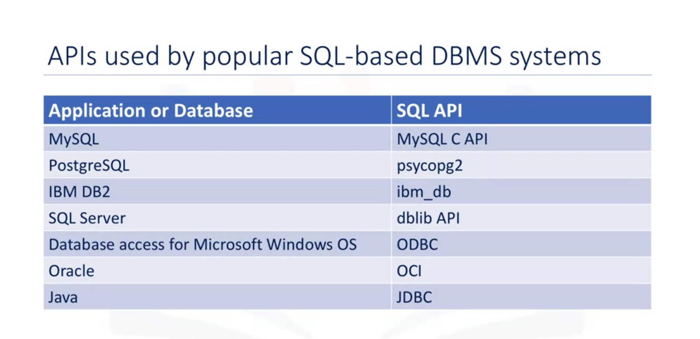
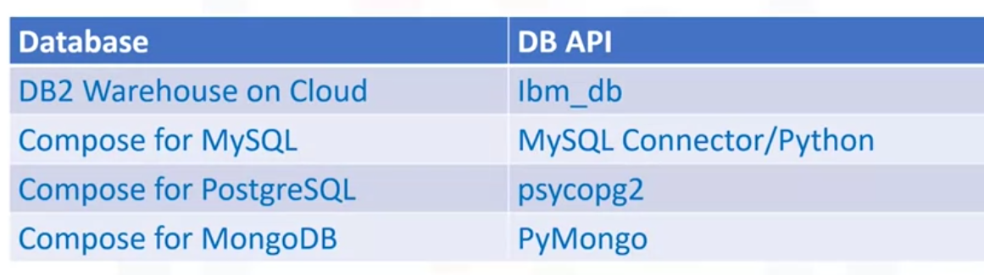
.
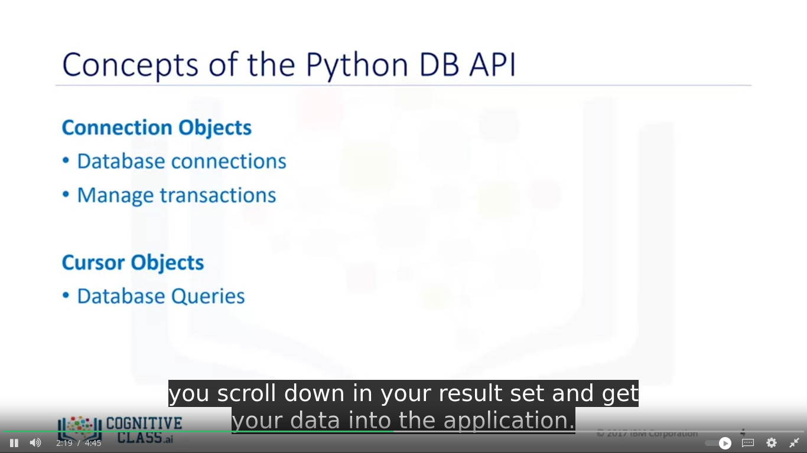
.
- Connection Methods:
  - cursor( ) → return cursor object using a connection
  - commit( ) → commit transaction to the database
  - rollback( ) → startback to any pending transaction
  - close( ) → close database connection

- Cursor Methods:
  - cursor.callproc(procname, args) # Call a stored procedure
  - cursor.execute(operation, params=None, multi=False) # Execute a SQL query or command
  - cursor.executemany(operation, seq_of_params) # Execute the same SQL operation with multiple sets of parameters
  - row = cursor.fetchone() # Fetch the next row of a query result set
  - rows = cursor.fetchmany(size=None) # Fetch the next set of rows of a query result set
  - all_rows = cursor.fetchall() # Fetch all remaining rows of a query result set
  - has_next_result_set = cursor.nextset() # Move to the next result set of a query
  - cursor.arraysize # Get or set the number of array elements to fetch with fetchmany()
  - cursor.close() # Close the cursor

- cursor used for data fetching, such as file handling methods in python
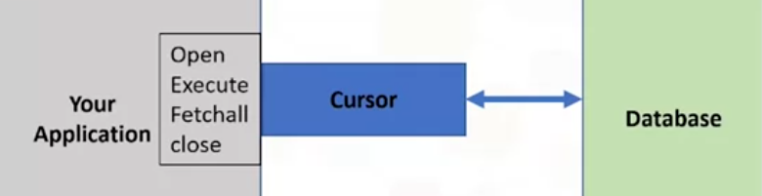
.
- sample code:
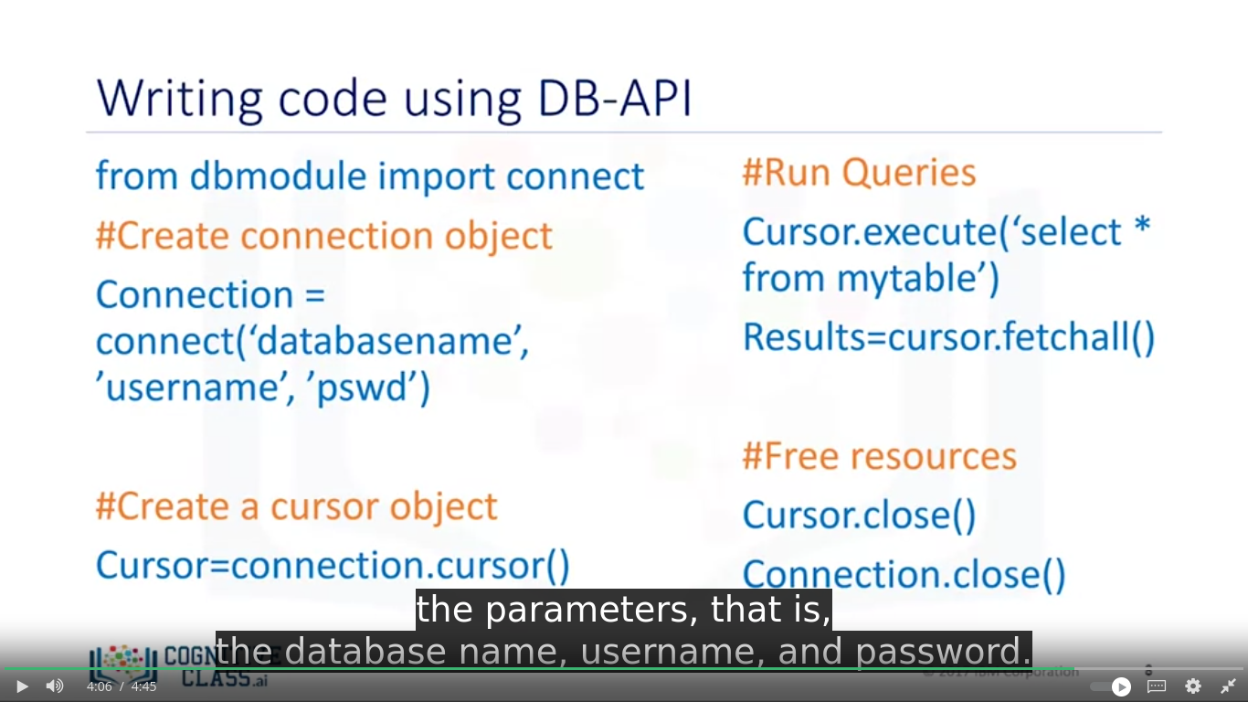

Hands-on Lab: Creating tables, inserting and querying Data
- Hands-on Lab: Creating tables, inserting and querying Data

Connecting to a database using ibm_db API
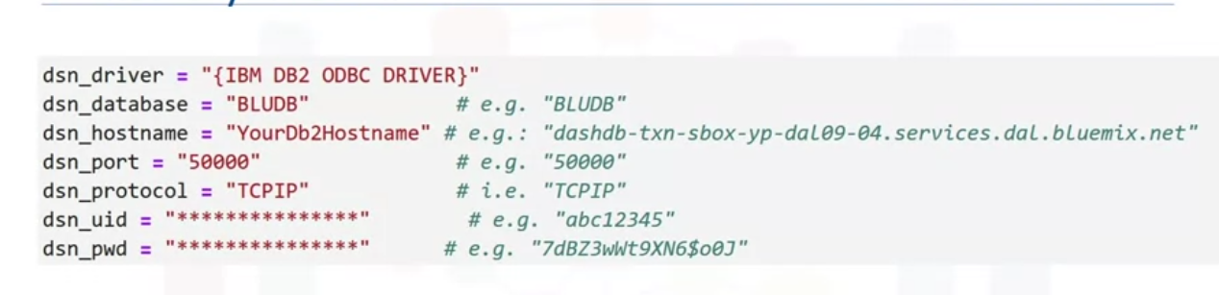
.

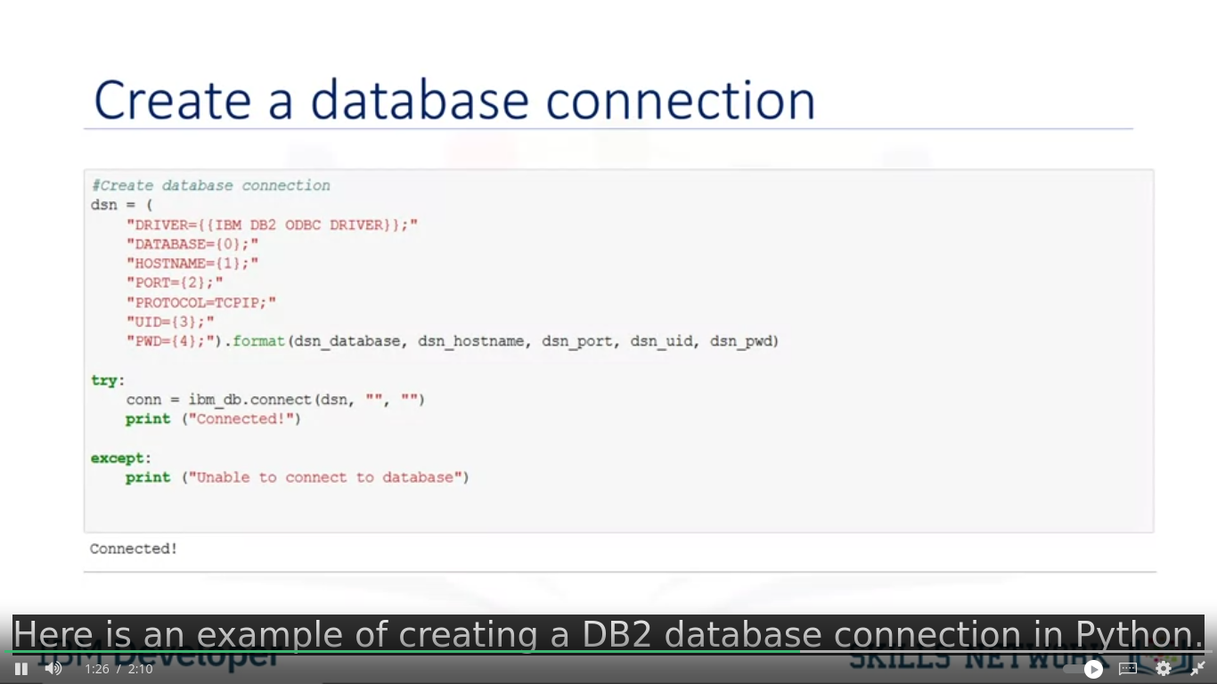
.
- CLOSE when you finish → clear resources

(Optional) Db2 Lab: Create Database Credentials
- (Optional) Db2 Lab: Create Database Credentials

(Optional) Db2 Lab: Connecting to a database instance
- (Optional) Db2 Lab: Connecting to a database instance

Creating tables, loading data and querying data
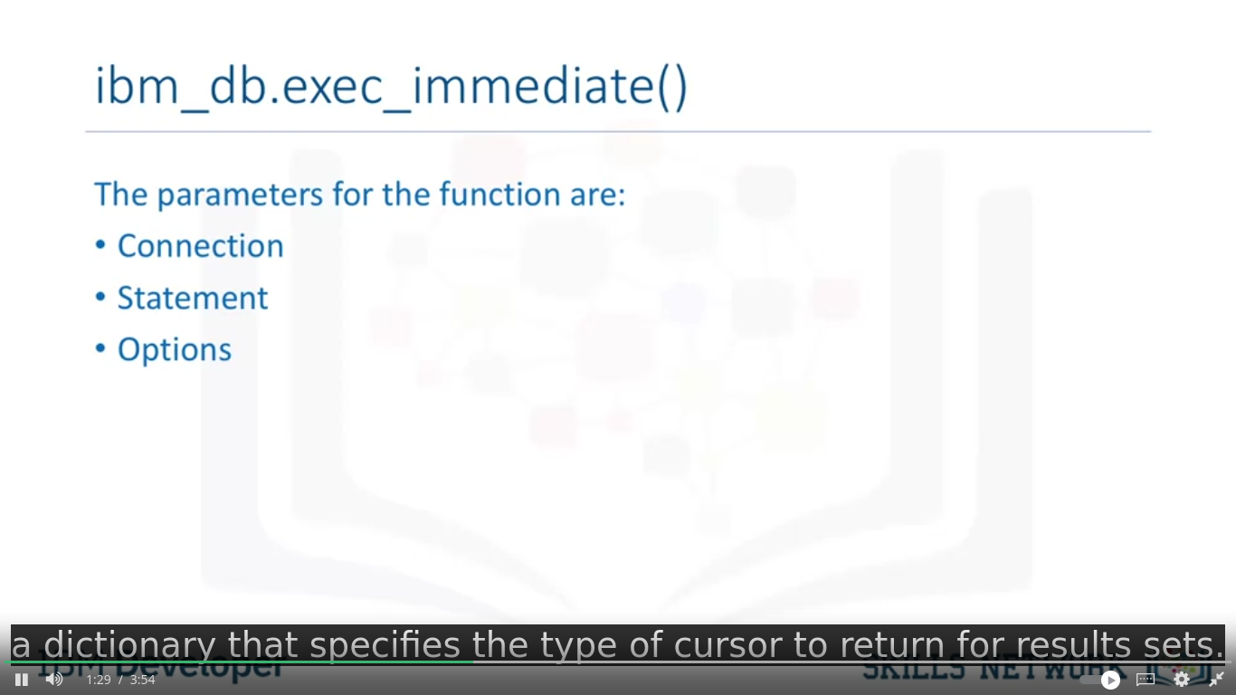
.

- Python
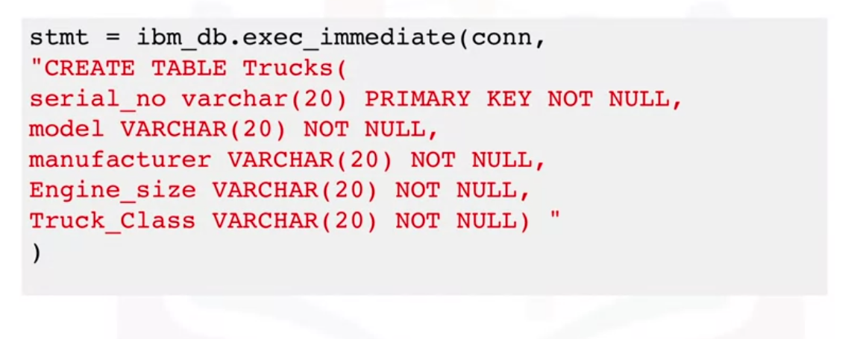
.
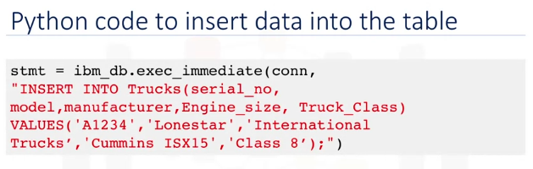
.
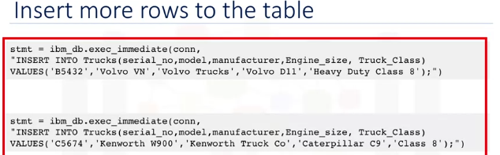
.
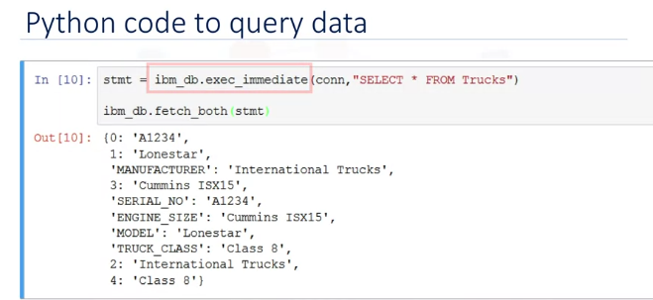
.
- Using Pandas
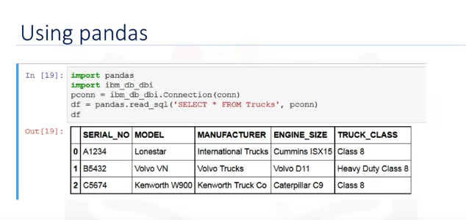
.

(Optional) Db2 Lab: Creating tables, inserting and querying Data
- (Optional) Db2 Lab: Creating tables, inserting and querying Data

Hands-on Tutorial: Accessing Databases with SQL magic
- Hands-on Tutorial: Accessing Databases with SQL magic

(Optional) Db2 Lab: Tutorial, Accessing Databases with SQL magic
- (Optional) Db2 Lab: Tutorial, Accessing Databases with SQL magic

Analyzing Data Using Python
- Hands-on Lab: Analyzing a real World Data Set

(Optional) Db2 Lab: Analyzing a real World Data Set
- (Optional) Db2 Lab: Analyzing a real World Data Set

Week 5: Course Assignment

Assignment Preparation: working with real-world data sets and built-in SQL functions

Working With Real World Datasets
- Querying data from table without knowing if it is uppercase or lowercase, general case → use “”
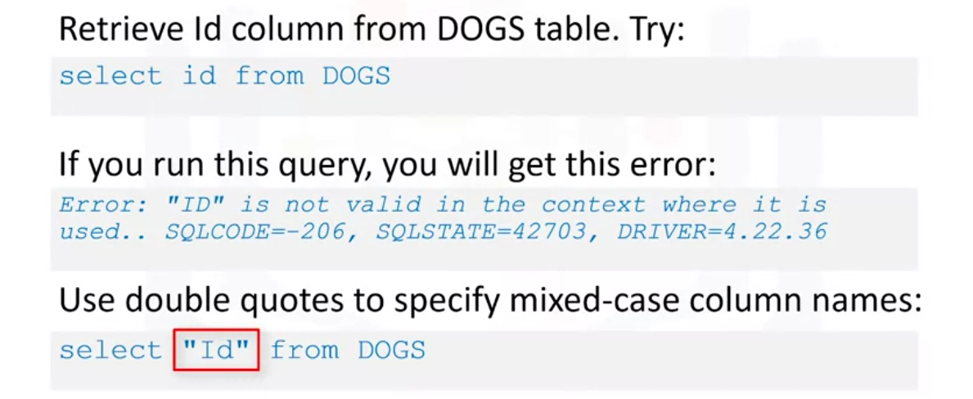
.
- Querying data from table with spaces or special characters → use “_” underscore
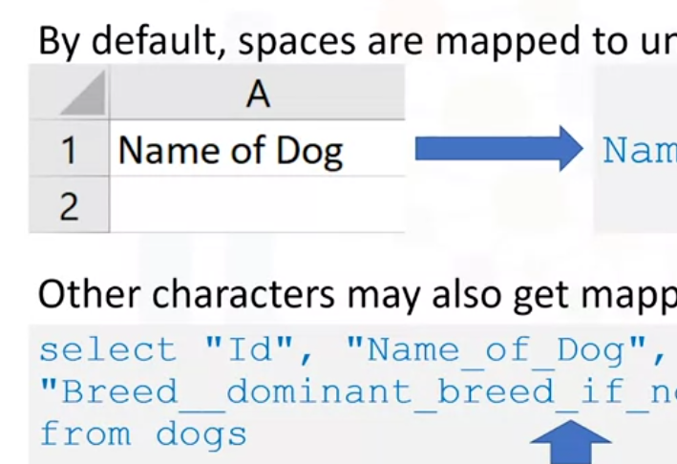
.
- using quotes in jupyter notebook querying
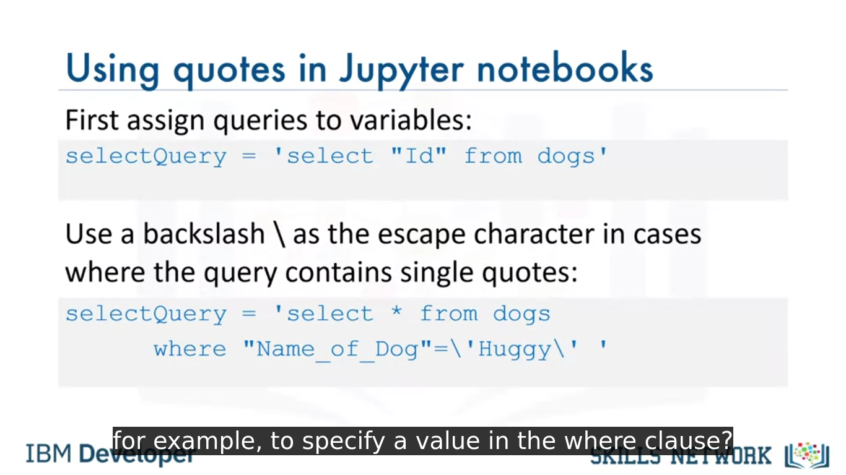
.
- multiple line SQL magic commanding
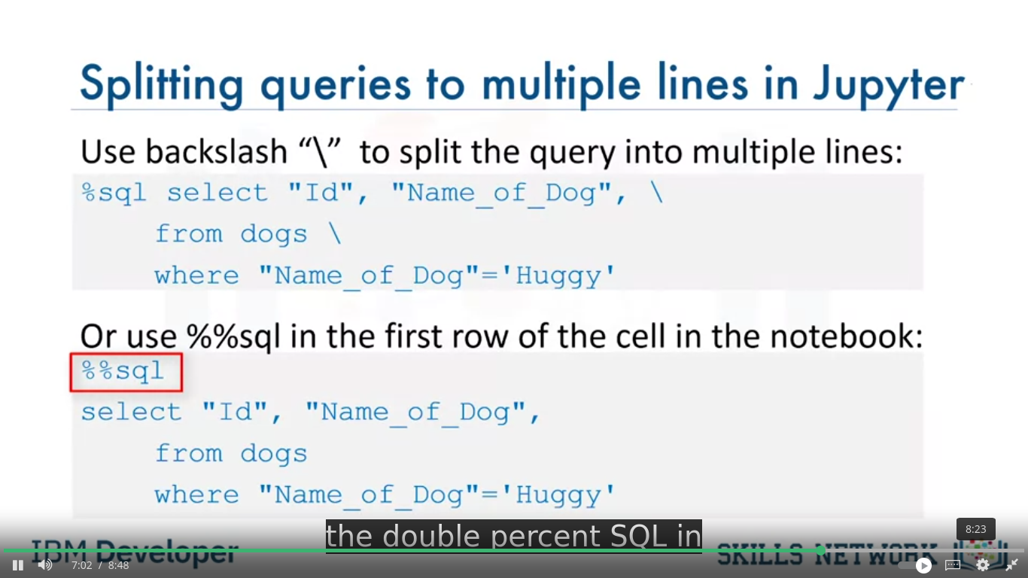
.

Getting Table and Column Details
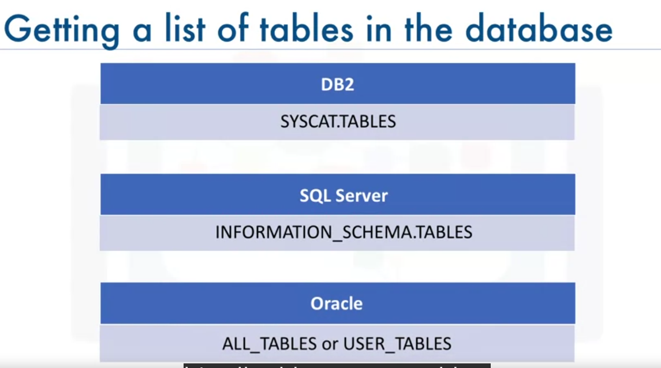
- use “%sql SELECT * FROM sqlite_master WHERE type='table'” → know number of tables in sqlite db
- use “%sql select count(*) from PRAGMA_table_info(“table_name”);” → number of columns of table in sqlite db

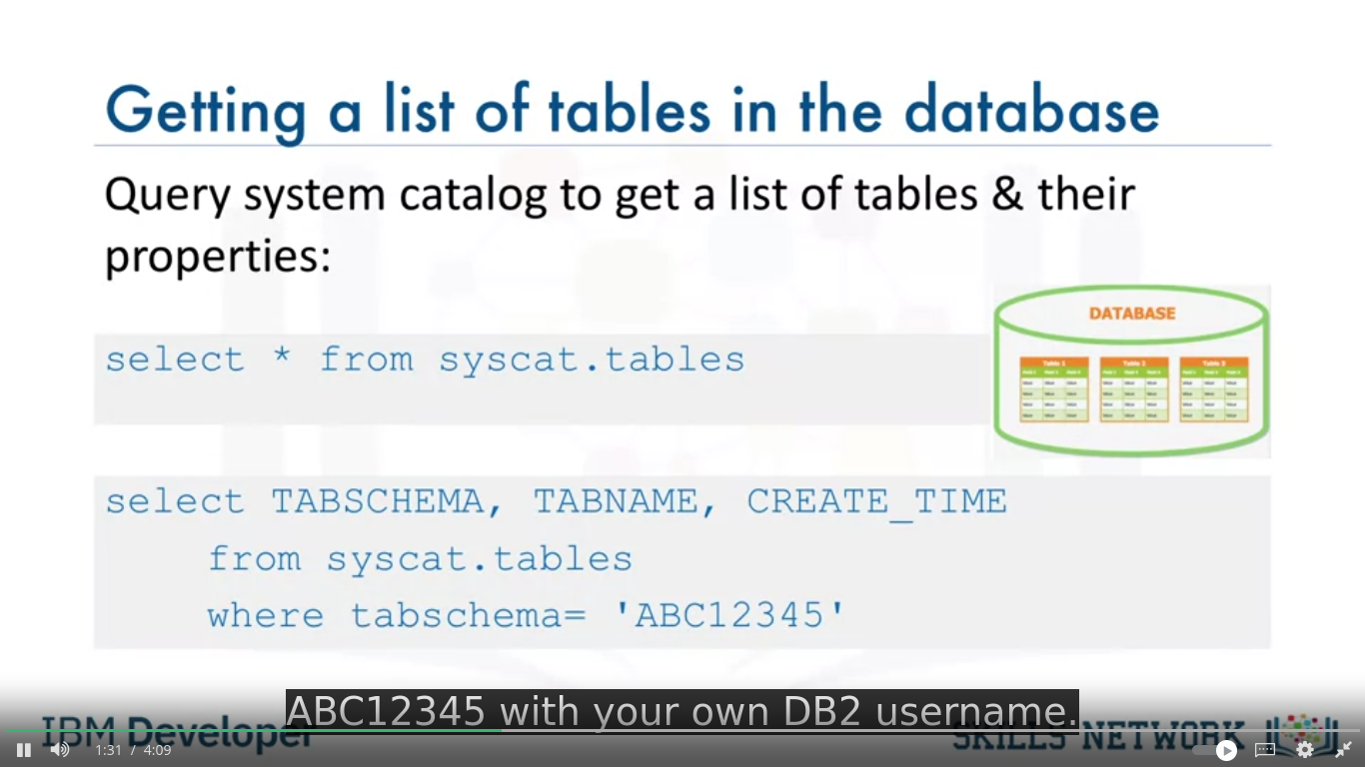
.
- table properties
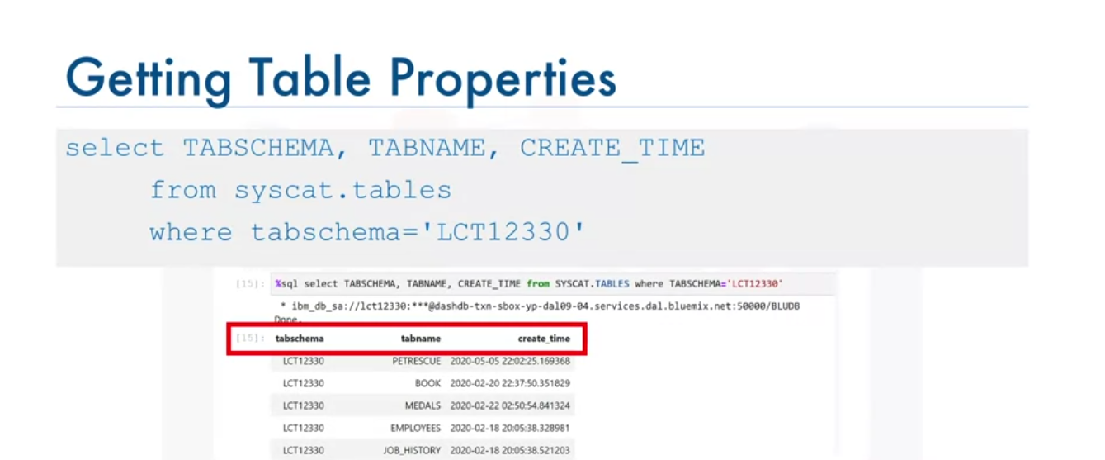
.
- list of columns in database
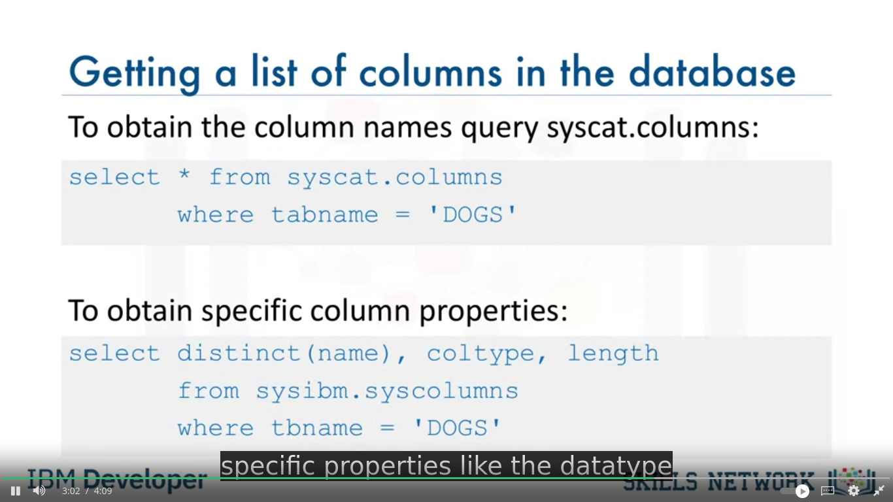
.
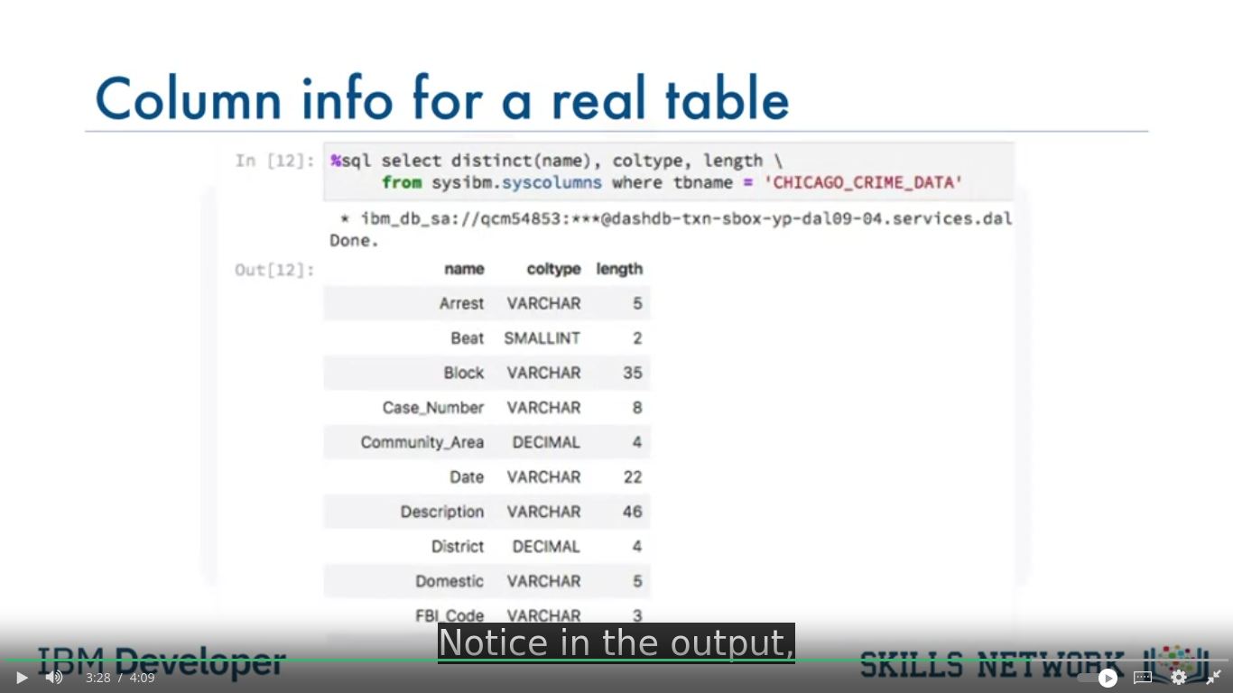
.

Hands-on Lab: Working with a real world data-set
- Hands-on Lab: Working with a real world data-set

(Optional)LOADing Data
- (Optional)LOADing Data

(Optional)Hands-on Lab: Practice Querying Real World Datasets
- (Optional)Hands-on Lab: Practice Querying Real World Datasets

Final Project
- Final Assignment: Database Qsqluerying using SQLite

Week 6:
Corps de texte.

Heading 2

Heading 3

Heading 2

Heading 3

Titre de colonne | Titre de colonne
Contenu | Contenu

Guides
- https://www.w3schools.com/sql/sql_alter.asp
- ipython-sqlmagic: https://github.com/catherinedevlin/ipython-sql

